Name: Ali Albayrak

Student ID: P304320

Question 5

1.Demonstrate how to use Java 2D graphics, e.g. simple shapes such as oval or square. Provide a sample code snippet or an executable application for demonstration.

I prefer to demonstrate how to draw an oval on the code comments.

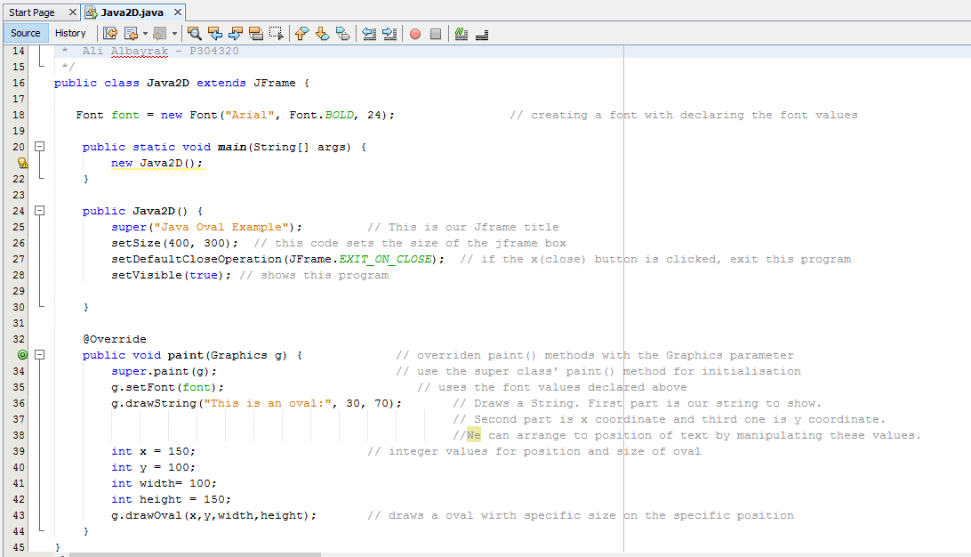

We can change the last method and draw other shaped easly.

Here is the output for this code:

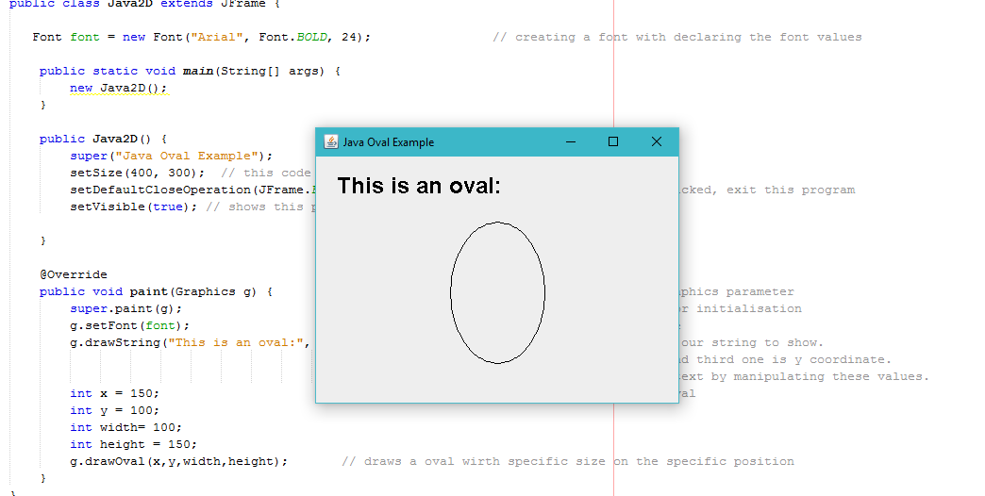

2. Demonstrate how to implement drag-and-drop in a Java program. Provide a sample code snippet or an executable application for demonstration.

I created a sample program to demonstrate drag and drop. We can drag and drop images and text in this code.

Note: As I am using images in this code, I imported them from my own path. So, path of images may need to be changed on different computer.

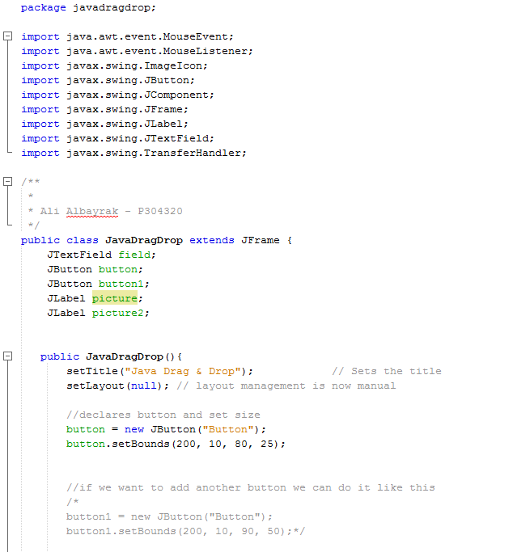

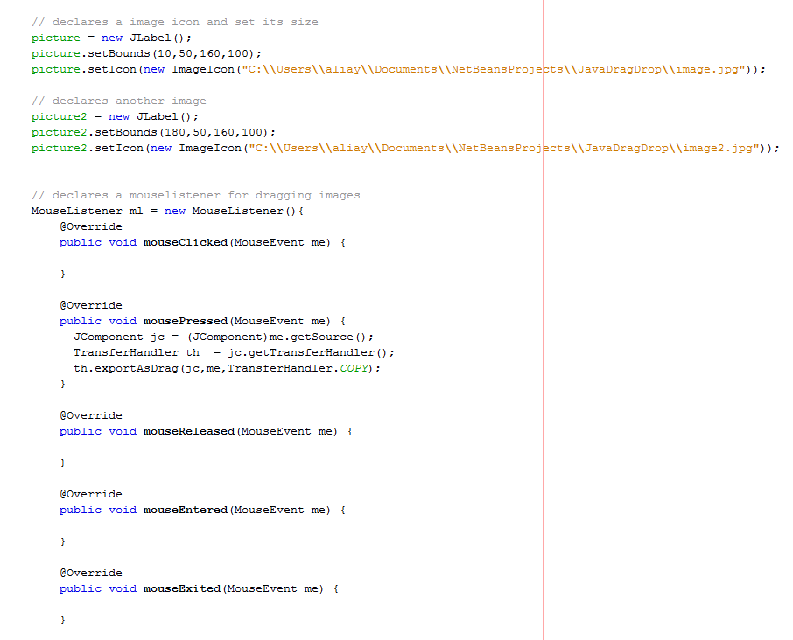

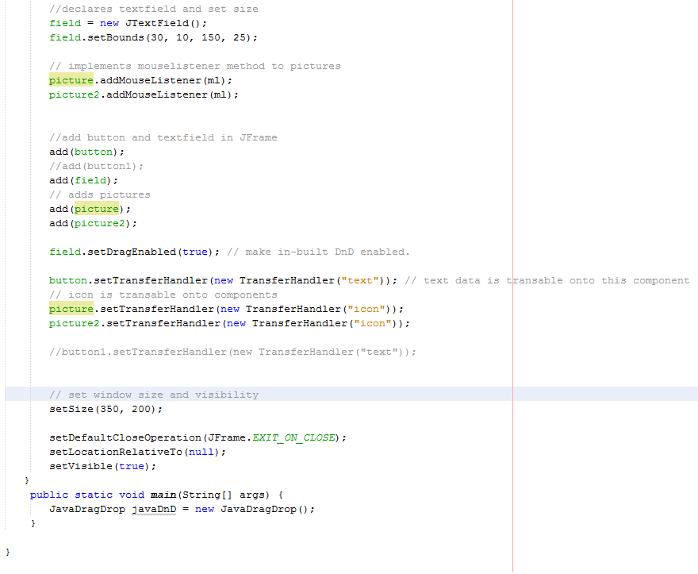

Output of this code:

Without Dragging:



After dragging text field to button:



After Dragging first image to second image(Opposite way works as well):



3. Demonstrate how to include GUI help files in Java. E.g. help contents in .html files. Provide a sample code snippet or an executable application for demonstration.

I created a sample program to demonstrate how to include GUI help files in java. When clicked on the help button, an html page with help instructions will open.

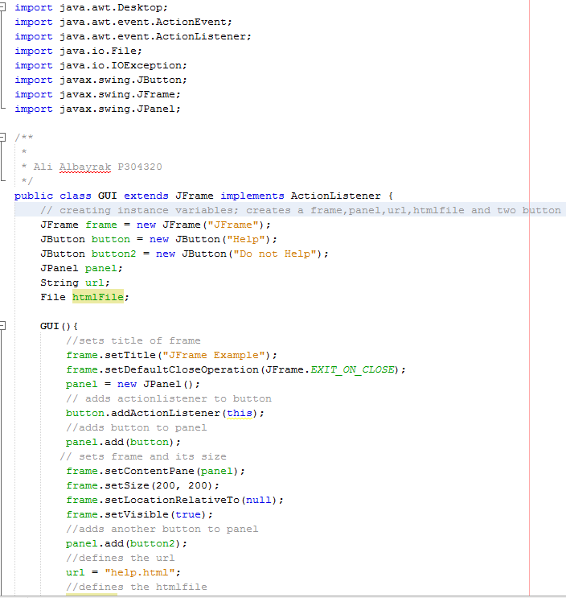

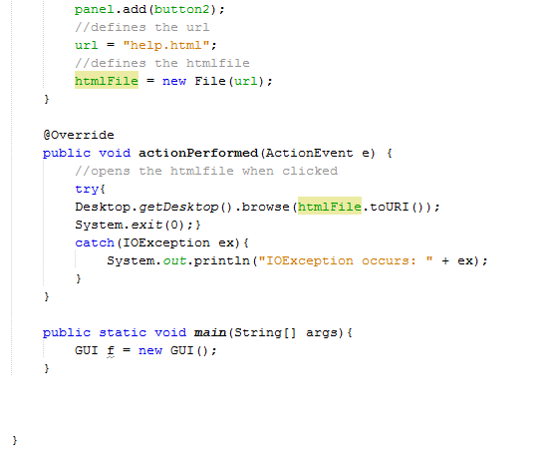

And here is the output:

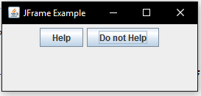

And html page:

